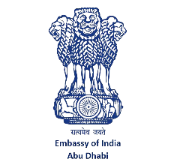

Advisory on Newborn Name Registration in the TAMM System

The Embassy has received many enquiries from Indian nationals regarding issues related to registrations of the name of newborns in the TAMM and Abu Dhabi Health Authority systems. The Ministry of Foreign Affairs of the United Arab Emirates has clarified that, under Federal Law No. 10 of 2022 regarding Birth and Death Registration, “a newborn’s compound or double name may not consist of more than two words”.
A compound or double name consisting of two words is permitted, but names with more than two words will be rejected.
Indian parents are therefore advised to ensure that the newborn’s name contains no more than two words when submitting applications through TAMM or the Health Authority. This will help avoid delays, rejections, and inconvenience during the registration process.

***

